**[ Laboratory No. 2.1:** **The sum N even integers]**

**Objectives:**

1. To know the loop construct in Python Programming
2. To create a program that take advantage of the loop mechanisms

**Materials:**

1. PC or Laptop
2. Python Package Development Kit
3. Pycharm or any IDE

**Background**

Python has two primitive loop constructs:

* while loops
* for loops

**While loop** can execute a set of statements as long as a condition is true.

### Example

Print i as long as i is less than 10:

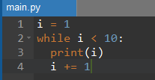



You may also would like to try this as if you want your output to show as follows:

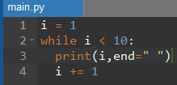



For loop uses range () function which returns a sequence of numbers, starting from 0 by default, and increments by 1 (by default), and ends at a specified number.

Example :

Loop that prints i from 0 to 10 in range 11.

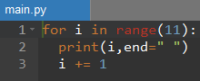



Or you would like to start by 1 you simply do this

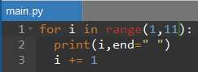



Or if you would like to increment by 2

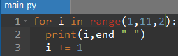



A for loop is used normally for iterating over a sequence (that is either a list, a tuple, a dictionary, a set, or a string).

**Instructions:**

1. Create class **SumOfNEven*[Surname]***
2. **Problem Scenario**
3. Write a python program that will compute ***the sum of the first N positive even*** integers.

For example

if **N is 3**, you should compute **2 + 4 +6 = 12**

1. **Input**

Input consist of a positive integer **N**, a value for the limits of iterations.

1. **Constraints**

1 ≤ N≤ ∞

1. **Output**

Your program should output the sum of the first N positive integers by the format as shown below:

If **N is 0**, display **“Invalid input”**

If **N is 4**, display **“2+4+6+8=20”**

1. **Source Codes**

|  |
| --- |
|  |

1. **Sample Input/Output**

**NOTE: Provide a screenshot and describe your observation for each action you performed based on the item below:**

* **Input zero or negative value for N such that -6, 4**
* **Input floating point value for N such that 3.7, 9.8**
* **Input any valid value for N**

1. **Submit your file with filename convention: SumOfNEven*[Surname]***

**Rules:**

1. Each laboratory activity has time limit of 1:30 minutes and is due on the day depending on the level of difficulty or constraints.
2. Each activity will only last every after 3 days and has deduction of 10 points every day from the day it was given.